**Equatorial Guinea country profile**

Published

8 May 2018

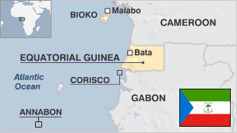

**Equatorial Guinea is a small country on the west coast of Africa which struck oil in 1995 and which is now being cited as a textbook case of the resource curse - or the paradox of plenty.**

It is made up of a mainland territory called Rio Muni, and five islands including Bioko, where the capital Malabo is located.

Since the mid 1990s the former Spanish colony has become one of sub-Sahara's biggest oil producers but a large proportion of the population still lives in poverty.

Rights organisations have described the two post-independence leaders as among the worst abusers of human rights in Africa.

The first president Francisco Macias Nguema's reign of terror - from independence in 1968 until his overthrow in 1979 - prompted a third of the population to flee.

* Read more [country profiles](http://news.bbc.co.uk/1/hi/country_profiles/) - Profiles by [BBC Monitoring](http://bbc.co.uk/monitoring)

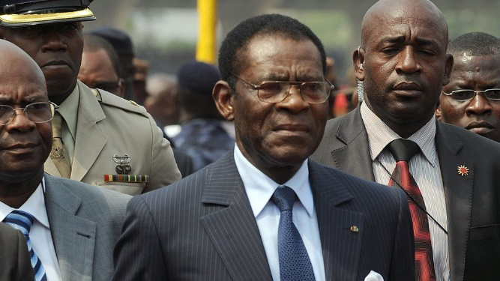image copyrightGetty Images

Mr Obiang Nguema is Africa's longest serving leader and has been described by rights organisations as one Africa's most brutal dictators.

He seized power in 1979.

According to Human Rights Watch, the ''dictatorship under President Obiang has used an oil boom to entrench and enrich itself further at the expense of the country's people''.

He has been pursued in French courts for allegedly plundering state coffers to buy luxury homes and cars in France.

His son and vice-president, Teodoro 'Teodorin' Nguema Obiang, has been resisting attempts by the US administration to seize his assets, denying charges that they were obtained with allegedly corrupt funds taken from his country.

* [Read full biography](http://www.bbc.co.uk/news/world-africa-13317176)

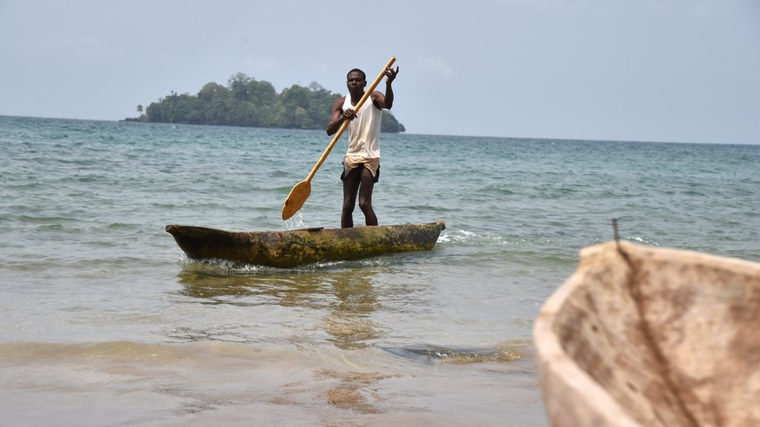image copyrightGetty Images

image captionOffshore oil and gas exports account for most of Equatorial Guinea's income

Equatorial Guinea's media outlets are closely controlled by the government. There are few private publications.

# Equatorial Guinea profile - Timeline

Published

8 May 2018

## A chronology of key events:

**1471** - Portuguese navigator Fernao do Po sights the island of Fernando Po, which is now called Bioko.

**1777** - Portuguese cedes islands of Annobon and Fernando Po as well as rights on the mainland coast to Spain, giving it access to a source of slaves.

**1844** - Spanish settle in what became the province of Rio Muni - mainland Equatorial Guinea.

**1904** - Fernando Po and Rio Muni become the Western African Territories, later renamed Spanish Guinea.

**1968** - Spanish Guinea granted independence and becomes the Republic of Equatorial Guinea with Francisco Macias Nguema as president.

**1972** - Nguema becomes president for life.

**1979** - Nguema ousted in military coup led by Teodoro Obiang Nguema Mbasogo.

## Elections boycott

**1993** - First multi-party elections are generally condemned as fraudulent and are boycotted by the opposition.

**1996** February - President Obiang Nguema wins 99% of votes in election amid reports of widespread irregularities.

**1996** March - Mobil oil corporation announces it has discovered sizeable new oil and gas reserves.

## Poor human rights record

**1998** January - Amnesty International reports the arrest of scores of people - mostly from the Bubi minority - in the wake of attacks on military posts on Bioko island.

**1998** June - Military tribunal sentences 15 people to death for separatist attacks on Bioko island.

**1999** March - Ruling Democratic Party of Equatorial Guinea wins majority of seats in parliamentary elections condemned as fraudulent. Dozens of members of main opposition Popular Union are arrested.

## Oil boost

**2001** - Economy emerges as one of world's fastest-growing because of oil exploitation. Opposition says trickle-down effect of growth is too slow, too small.

**2001** March - Eight exiled opposition parties form a coalition in Spain to overhaul politics at home, saying democracy under Obiang is a sham.

**2001** July - Exiled politician Florentino Ecomo Nsogo, head of the Party of Reconstruction and Social Well-Being (PRBS), returns home as the first opposition figure to respond to an appeal by President Obiang Nguema, who wants opposition parties to register.

## Mass trial

**2002** June - Court jails 68 people for up to 20 years for alleged coup plot against President Obiang Nguema. They include main opposition leader Placido Mico Abogo. EU is concerned that confessions were obtained under duress. Amnesty International says many defendants showed signs of torture.

**2002** December - President Obiang Nguema re-elected. Authorities say he won 100% of the vote. Opposition leaders had pulled out of the poll, citing fraud and irregularities.

**2003** August - Exiled opposition leaders form self-proclaimed government-in-exile in Madrid, Spain.

Opposition leader Placido Mico Abogo and 17 other political prisoners released.

Coup arrests

**2004** March - Suspected mercenaries arrested over alleged coup attempt; group is linked to suspected mercenaries detained in Zimbabwe. Crackdown on immigrants ensues; hundreds of foreigners deported.

**2004** April - Parliamentary elections: President Obiang's party and its allies take 98 of 100 seats. Foreign observers criticise poll and result.

**2004** August-November- Foreigners accused of plotting coup to overthrow President Obiang are tried in Malabo. Their South African leader is sentenced to 34 years in jail.

Simon Mann, the British leader of a group of mercenaries accused of involvement in the alleged coup plot and arrested in Zimbabwe, is tried in Harare and sentenced to seven years in jail there. His sentence is later reduced to four years on appeal.

**2005** January - Sir Mark Thatcher, son of former British PM Margaret Thatcher, tells a South African court that he helped to finance the alleged 2004 coup plot, but did so unwittingly.

**2005** June - President amnesties six Armenians convicted of taking part in the alleged 2004 coup plot.

**2005** July - 55 people killed when passenger aircraft crashes shortly after take-off from Malabo.

**2005** September - Military court jails 23 defendants, most of them military officers, who are accused of plotting a coup in 2004.

**2005** December - Spain withdraws the asylum status of exiled opposition leader Severo Moto saying he was involved in several coup attempts.

**2006** August - The government resigns en masse. The president had accused it of corruption and poor leadership. Key ministers are reappointed.

**2006** October - President Obiang says Equatorial Guinea plans to double its revenue share from oil production contracts.

**2007** May - New airline launched to replace the national carrier EGA which was forced to shut over safety concerns.

**2007** November - Four Equatorial Guineans sentenced for alleged role in 2004 coup plot.

**2008** February - British mercenary Simon Mann is extradited from Zimbabwe to Equatorial Guinea to stand trial for his alleged role in 2004 coup plot.

**2008** March - Spain restores exiled opposition leader Severo Moto's asylum status.

**2008** April - Spanish police arrest Mr Moto on suspicion of trying to ship weapons to Equatorial Guinea.

**2008** July - President Obiang accepts resignation of the entire government, accusing it of corruption and mismanagement; appoints Ignacio Milam Tang as new prime minister.

British mercenary Simon Mann and four South Africans sentenced to 34 years in prison for taking part in 2004 coup plot. They are pardoned and released in November 2009.

**2008** October - Cameroon charges two policemen with kidnapping rebel colonel Cipriano Nguema Mba and returning him to Equatorial Guinea, which denies all knowledge.

## Presidential palace attack

**2009** February - Presidential palace allegedly comes under attack. Seven Nigerians are later jailed over the incident.

**2009** November - Presidential elections. President Obiang wins again.

**2010** August - Four alleged coup plotters are executed within hours of being found guilty.

**2010** October - Controversy over United Nations agency Unesco plans to grant a scientific research prize sponsored by President Obiang. The prize is approved but Mr Obiang's name is dropped from its title.

**2010** November - French appeal court authorises probe of corruption charges against three African heads of state, including President Obiang.

**2011** June - Amnesty International alleges wave of arrests targeting political opponents, migrants and students ahead of African Union summit in Malabo.

**2011** November - Referendum on constitutional changes, which critics describe as a power grab.

**2012** January - Equatorial Guinea co-hosts Africa Cup of Nations, the continent's biggest football tournament.

President's son, Teodorin, asks US court to dismiss a US bid to seize $71 million worth of his assets, denying they were obtained through corruption.

**2012** May - Teodorin is promoted to vice president.

**2012** July - France issues arrest warrant for Teodorin, in a probe into alleged misspending of public funds.

**2013** May - Opposition activists are arrested in run-up to parliamentary elections.

**2014** March - Teodorin is put under formal investigation in France over money laundering allegations. He denies embezzling state funds.

**2014** October - Teodorin is forced to relinquish more than 30 million dollars of assets in the United States, which the authorities there say were bought with stolen money.

President Obiang grants an amnesty for political crimes, as part of efforts to convince exiled politicians and other opposition figures to join a "national dialogue".

**2014** November - Equatorial Guinea is chosen to replace Morocco as host of the 2015 African Cup of Nations, after Morocco refused to host the competition because of fears about Ebola.

Government says its national dialogue with political parties has led to agreement in some areas.

**2015** January - Police arrest opposition politician Celestino Nvo Okenve and human rights activist Santiago Martin over their calls for a boycott of the African Cup of Nations.

**2016** April - Teodoro Obiang gains another term of office in elections.

**2016** February - Government moves its headquarters from Malabo to Djibloho, also known as Oyala, an unfinished city deep in the rainforest.

**2017** October - A French court hands down a three-year suspended jail sentence to Vice-President Teodorin Obiang for embezzlement, money laundering and corruption.

**2018** January - The authorities say they thwarted an attempted coup the previous month.

**2018** May - Supreme Court upholds ban on the country's main opposition party, the CI Party, which is accused of involvement in acts of violence ahead of last year's elections.